**Assignment 4**

**Group: DWDM19G04**

**Roll Numbers: 2016BTECS00063, 2016BTECS00081, 2016BTECS00103**

**Batch: B7**

**Date: 14th September, 2019**

**Title: Classifications**

**Problem Statement:**

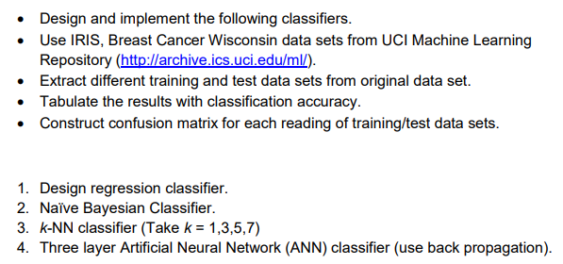

**Theory:**

**Iris Dataset:**

This is perhaps the best-known database to be found in the pattern recognition literature. Fisher's paper is a classic in the field and is referenced frequently to this day. The data set contains 3 classes of 50 instances each, where each class refers to a type of iris plant. One class is linearly separable from the other 2; the latter are NOT linearly separable from each other.

**Regression Classifier:**

Multinomial logistic regression is a [classification](https://en.wikipedia.org/wiki/Statistical_classification) method that generalizes [logistic regression](https://en.wikipedia.org/wiki/Logistic_regression) to [multiclass problems](https://en.wikipedia.org/wiki/Multiclass_classification), i.e. with more than two possible discrete outcomes. That is, it is a model that is used to predict the probabilities of the different possible outcomes of a [categorically distributed](https://en.wikipedia.org/wiki/Categorical_distribution) [dependent variable](https://en.wikipedia.org/wiki/Dependent_variable), given a set of [independent variables](https://en.wikipedia.org/wiki/Independent_variable). (which may be real-valued, binary-valued, categorical-valued, etc.).

**Naïve Bayesian Classifier:**

 naïve Bayes classifiers are a family of simple "[probabilistic classifiers](https://en.wikipedia.org/wiki/Probabilistic_classification)" based on applying [Bayes' theorem](https://en.wikipedia.org/wiki/Bayes%27_theorem) with strong (naïve) [independence](https://en.wikipedia.org/wiki/Statistical_independence) assumptions between the features.

Naïve Bayes classifiers are highly scalable, requiring a number of parameters linear in the number of variables (features/predictors) in a learning problem. [Maximum-likelihood](https://en.wikipedia.org/wiki/Maximum-likelihood_estimation) training can be done by evaluating a [closed-form expression](https://en.wikipedia.org/wiki/Closed-form_expression), which takes [linear time](https://en.wikipedia.org/wiki/Linear_time), rather than by expensive [iterative approximation](https://en.wikipedia.org/wiki/Iterative_method) as used for many other types of classifiers.

**k-NN classifier:**

the k-nearest neighbors algorithm (k-NN) is a [non-parametric](https://en.wikipedia.org/wiki/Non-parametric_statistics) method used for [classification](https://en.wikipedia.org/wiki/Statistical_classification) and [regression](https://en.wikipedia.org/wiki/Regression_analysis).[[1]](https://en.wikipedia.org/wiki/K-nearest_neighbors_algorithm#cite_note-1) In both cases, the input consists of the k closest training examples in the [feature space](https://en.wikipedia.org/wiki/Feature_space). In k-NN classification, the output is a class membership. An object is classified by a plurality vote of its neighbors, with the object being assigned to the class most common among its k nearest neighbors (k is a positive [integer](https://en.wikipedia.org/wiki/Integer), typically small). If k = 1, then the object is simply assigned to the class of that single nearest neighbor. k-NN is a type of [instance-based learning](https://en.wikipedia.org/wiki/Instance-based_learning), or [lazy learning](https://en.wikipedia.org/wiki/Lazy_learning), where the function is only approximated locally and all computation is deferred until classification. The neighbors are taken from a set of objects for which the class (for k-NN classification) is known. This can be thought of as the training set for the algorithm, though no explicit training step is required.

**ANN Classifier:**

ANN Classification is an example of Supervised Learning. Known class labels help indicate whether the system is performing correctly or not. This information can be used to indicate a desired response, validate the accuracy of the system, or be used to help the system learn to behave correctly. The known class labels can be thought of as supervising the learning process; the term is not meant to imply that you have some sort of interventionist role. An ANN is based on a collection of connected units or nodes called [artificial neurons](https://en.wikipedia.org/wiki/Artificial_neuron), which loosely model the [neurons](https://en.wikipedia.org/wiki/Neuron) in a biological brain. Each connection, like the [synapses](https://en.wikipedia.org/wiki/Synapse) in a biological brain, can transmit a signal to other neurons. An artificial neuron that receives a signal then processes it and can signal neurons connected to it.

**Output:**

1. **Regression Classifier:**

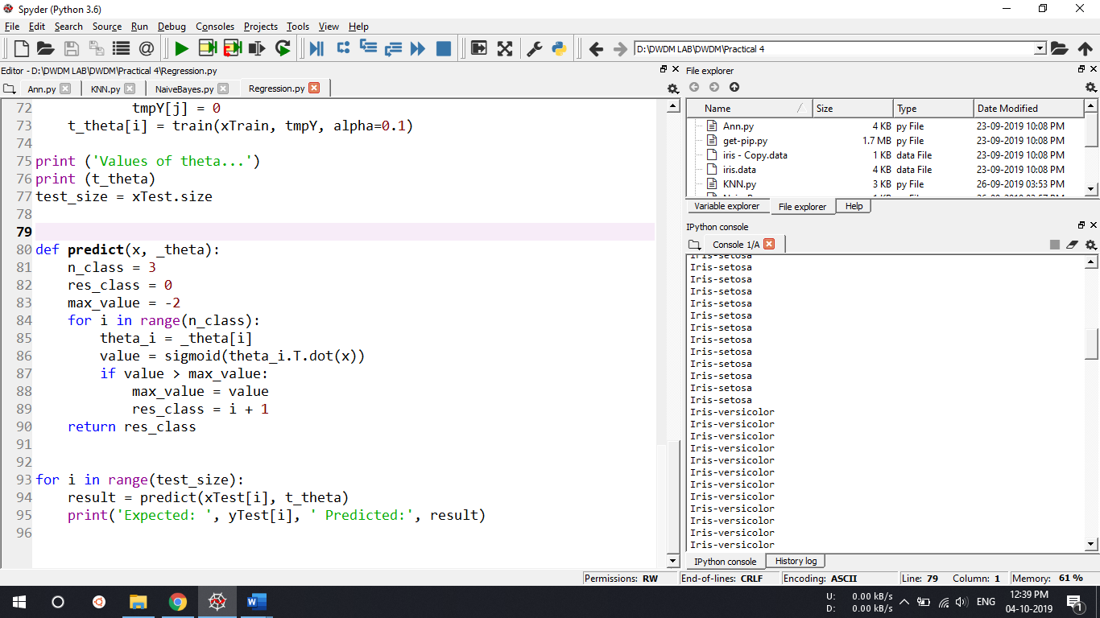

1. **Naïve Bayesian Classifier:**

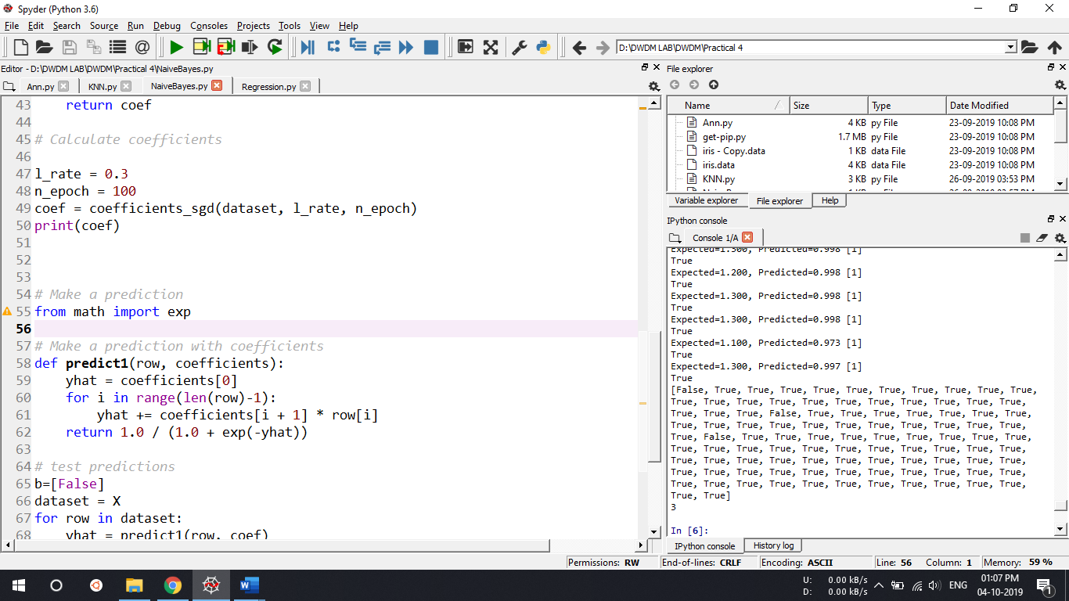

1. **k-NN classifier:**

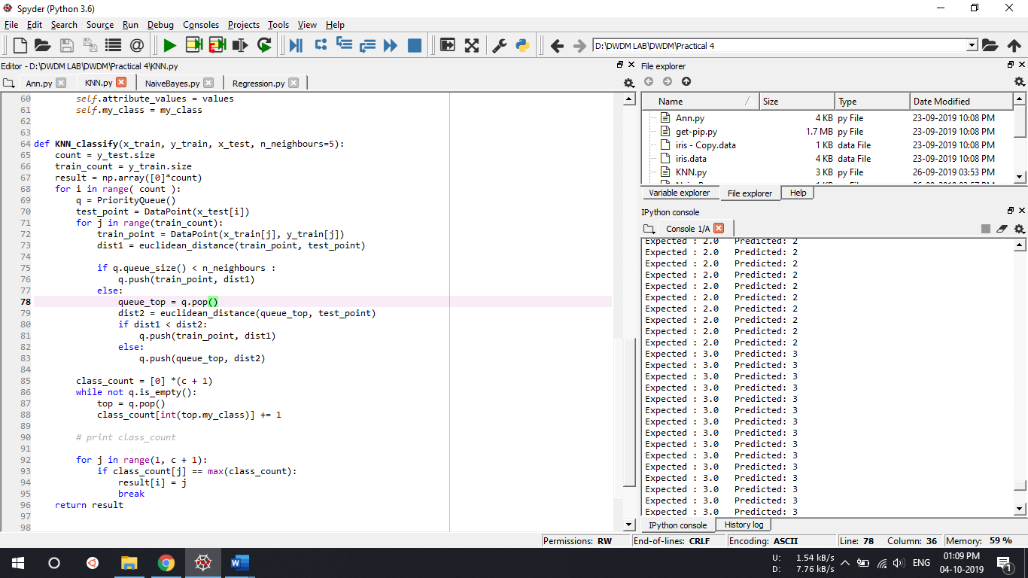

1. **ANN Classifier:**

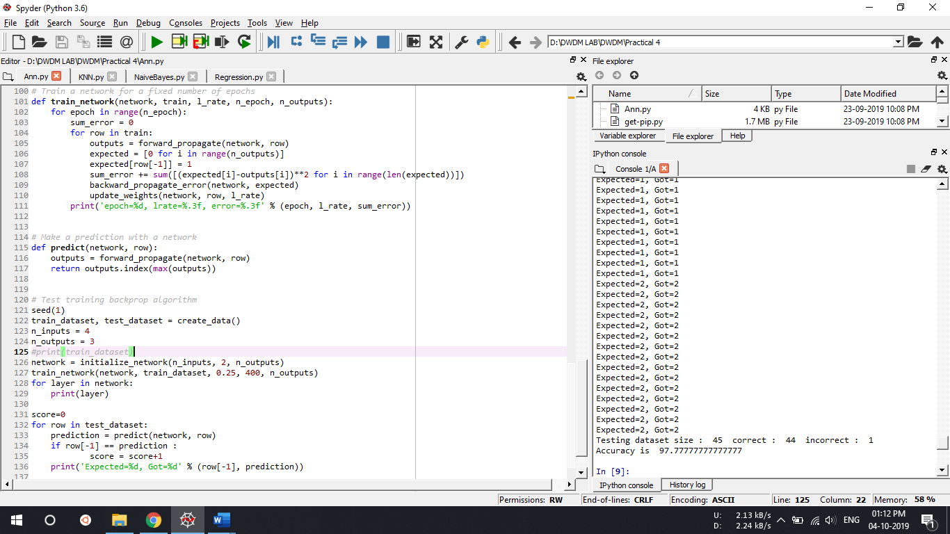

**Conclusion:**

We studied and implemented different Machine Learning algorithms on iris dataset.